MANAGING & INTERACTING WITH DOCKER CONTAINERS

DOCKER COMMANDS
- docker ps ----------------------------- to check the running containers
- docker ps -a -------------------------- to check the running as well as existed containers
- docker images ----------------------- to check the created images
- docker image ls ---------------------- to check the images
- docker search httpd ---------------- to search the image in dockerhub
- docker pull (httpd) ------------------ to pull the image from dockerhub
- docker run (httpd) ------------------ the container run in foreground
- docker run -d (httpd) --------------- the container run in background
- docker kill (container ID) ----------- to kill the container
- docker start (container ID) --------- to start the container
- docker stop (container ID) ---------- to stop the container
- docker inspect (container ID)------- to check all the info about the container
- docker run -d -p (httpd) -------------- to assign manual port to the container
- docker run -d -P (httpd) --------- to assign random port to container (32768-64000)
- docker top (container ID) -------------- to get containers process related information
- docker port (container ID) --------------to check the port of container
- docker logs (container ID) -------------- to check the logs of a container
- docker stop $(docker ps -q) -------------to stop all the running containers
- docker rm $(docker ps -aq) -------------to remove all the existed container
- docker rmi $(docker images -q) --------to remove all the images
- docker rmi -f $(docker images -q) -----to remove images forcefully
- docker rm -f (container ID) ------------- to remove the container
- docker rename (1st name) (2nd name) ------to rename a container
- docker stats (container ID) ------------to check the cpu utilization of every container

DOCKER CONTAINER LIFECYCLE
- docker start
- docker stop
- docker rm
- docker prune

EXPOSE APPLICATION TO THE WORLD
- docker run -d -p 8081:80 --name nginx_container --rm nginx
- docker ps
- docker inspect nginx_container | grep “IP”
private_ip: 172.17.0.2
- <public_ip:8081> -----> hit it on the web
Note:
- -d ----------> run in detach mode
- -p ----------> to assign a manual port
- –name ----> to get the name to the container
- –rm --------> automatically remove container after stop
- Inspect ----> to get all the info about the container

Port Explanation:
- 8081 -----> server host port ----> port on your system
- 80 --------> cont. port ----> port inside container

When someone hits port 8081 on my system, send that request to port 80 inside the container

How it works:
- You open browser → http://public_ip:8081
- Request goes to:
  - Host port 8081
  - Docker forwards it to container port 80
  - NGINX inside container responds
- Bridge Network is Docker’s default private network that allows containers to communicate internally and connect to the outside world through port mapping.

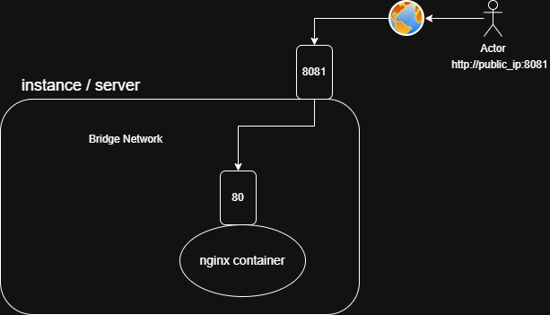

DOCKER EXEC
1.docker run -d -p 8081:80 –name nginx –rm nginx
2.docker ps
3.docker exec -it nginx /bin/bash
- cd usr/share/nginx/html/
- echo “hello nginx” > index.html
- exit
7.docker ps
8.<public_ip:8081>

Note:
- exec ------------> to go inside a running container
- /bin/bash -----> Open Bash shell inside container
- -it ---------------> to get interactive terminal
- -i ----------------> keep input open
- t -----------------> to get the terminal

HOW TO CHANGE THE DEFAULT NGINX PAGE
- docker run -d -p 8081:80 –name nginx –rm nginx
- vim index.html
Welcome to docker
- docker cp index.html nginx:/usr/share/nginx/html/index.html
- <public_IP:80811>

